**Assignment-1**

1. **What is software? What is software engineering?**

Software refers to a collection of programs, data, and instructions that enable a computer to perform specific tasks or functions. It includes both application software (such as word processors, games, and web browsers) and system software (such as operating systems and device drivers).

Software engineering is the systematic approach to designing, developing, testing, and maintaining software. It involves using engineering principles to create reliable, efficient, and high-quality software systems.

1. **Explain the types of software.**

**System Software:** This includes operating systems, device drivers, and utility programs that manage and control computer hardware.

**Application Software:** These are programs designed to perform specific tasks for users, such as word processors, spreadsheets, web browsers, and games.

**Middleware:** Software that acts as a bridge between application software and system software, often used in networking and distributed systems.

**Embedded Software:** Software that is embedded within devices or systems, such as firmware in electronic devices.

Programming Software: Tools used by developers to write, debug, and test software code.

1. **What is SDLC? Explain each phase of SDLC**

SDLC stands for Software Development Life Cycle. It's a structured process used to design, develop, and maintain software.

The phases are:

**Requirements Analysis:** Gather and analyze requirements from stakeholders.

**System Design:** Create a high-level design of the software's architecture.

Implementation: Develop the actual code based on the design.

**Testing:** Thoroughly test the software to identify and fix bugs.

**Deployment:** Install and release the software for users.

**Maintenance:** Regularly update and improve the software based on user feedback and changing requirements.

1. **What is DFD? Create a DFD diagram on Flipkart**

DFD stands for Data Flow Diagram. It's a graphical representation of how data flows within a system.

**DFD:**

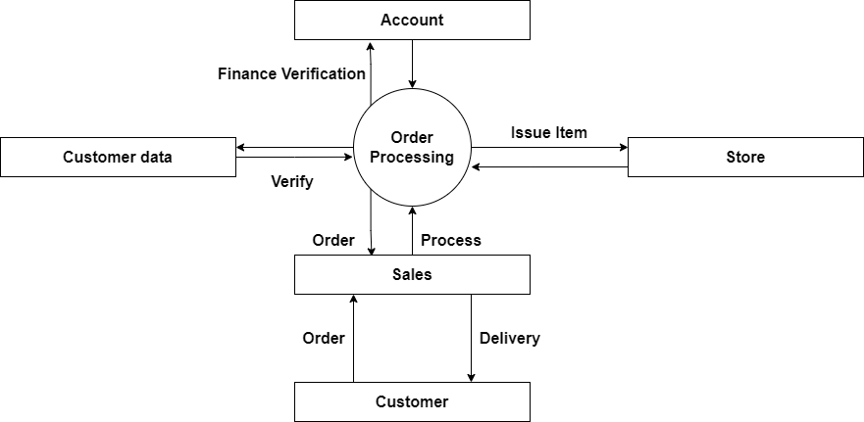

1. **What is Flow chart? Create a flowchart to make addition of two numbers**

A flowchart is a graphical representation of a process or algorithm using symbols and arrows to show the flow of steps.

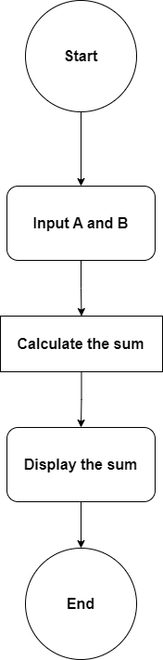

1. **What is Use case Diagram? Create a use-case on bill payment on Paytm.**

A use case diagram visually represents interactions between users and a system.

**Use Case Diagram:**

